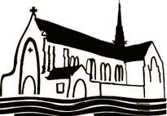
National Catholic Swimming & Diving Championship

January 17-19, 2020

Loyola University Maryland

Qualifying Times

Event | Girls | Boys
200 Yard Medley Relay | 2:06.49 | 1:46.50
200 Yard Freestyle | 2:15.50 | 1:57.50
200 Yard Individual Medley | 2:35.00 | 2:14.00
50 Yard Freestyle | 28.50 | 24.50
100 Yard Butterfly | 1:10.50 | 58.50
100 Yard Freestyle | 1:01.50 | 53.00
500 Yard Freestyle | 5:40.00 | 5:20.00
200 Yard Freestyle Relay | 1:48.50 | 1:37.00
100 Yard Backstroke | 1:10.00 | 1:01.00
100 Yard Breaststroke | 1:18.00 | 1:07.50
400 Yard Freestyle Relay | 4:21.00 | 3:40.00

